EXPERIMENT NO. 1

AIM :- To write a C program to simulate a DFA.

ALGORITHM:-

1. Ask the user to input the number of states
2. Ask the user to provide the number of final states
3. Get set of final states
4. Store set of final states in an array
5. Get transition function from the user
6. Store the transition function and some suitable data structure (2 dimensional array or Link list)
7. Ask the user to provide the input string
8. Calculate the length of string. Let it be k.
9. set i=1, state=initial state
10. state=transition_function(state, ith character of the string)
11. if i!=k go to step 10
12. If state is in final state string accepted else string rejected

CODE:-

#include <stdio.h>

#define TOTAL_STATES 2

#define FINAL_STATES 1

#define ALPHABET_CHARCTERS 2

#define UNKNOWN_SYMBOL_ERR 0

#define NOT_REACHED_FINAL_STATE 1

#define REACHED_FINAL_STATE 2

enum DFA_STATES{q0,q1};

enum input{a,b};

int Accepted_states[FINAL_STATES]={q1};

char alphabet[ALPHABET_CHARCTERS]={'a','b'};

int Transition_Table[TOTAL_STATES][ALPHABET_CHARCTERS];

int Current_state=q0;

void DefineDFA()

{

Transition_Table[q0][a] = q1;

Transition_Table[q0][b] = q0;

Transition_Table[q1][a] = q1;

Transition_Table[q1][b] = q0;

}

int DFA(char current_symbol)

{

int i,pos;

for(pos=0;pos<ALPHABET_CHARCTERS; pos++)

if(current_symbol==alphabet[pos])

break;//stops if any character other than a or b

if(pos==ALPHABET_CHARCTERS)

return UNKNOWN_SYMBOL_ERR;

for(i=0;i<FINAL_STATES;i++)

if((Current_state=Transition_Table[Current_state][pos])

==Accepted_states[i])

return REACHED_FINAL_STATE;

return NOT_REACHED_FINAL_STATE;

}

int main(void)

{

char current_symbol;

int result;

DefineDFA(); //Fill transition table

printf("Enter a string with 'a' s and 'b's:\n Press Enter Key to stop\n");

while((current_symbol=getchar())!= '\n')

if((result= DFA(current_symbol))==UNKNOWN_SYMBOL_ERR)

break;

switch (result) {

case UNKNOWN_SYMBOL_ERR:printf("Unknown Symbol %c",

current_symbol);

break;

case NOT_REACHED_FINAL_STATE:printf("Not accepted"); break;

case REACHED_FINAL_STATE:printf("Accepted");break;

default: printf("Unknown Error");

}

printf("\n\n\n");

return 0;

}

OUTPUT:-

CASE 1:-

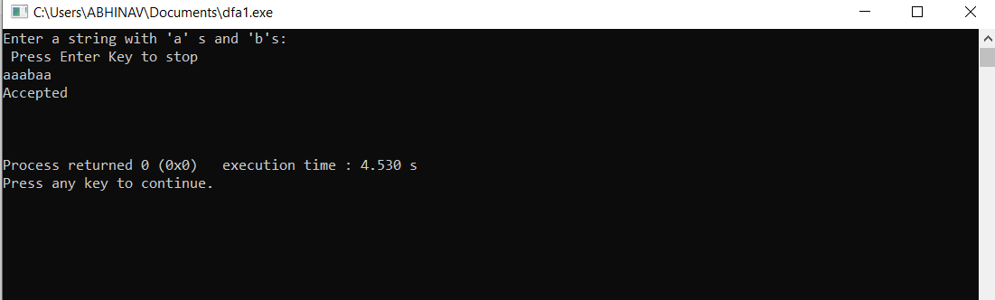

CASE 2:-

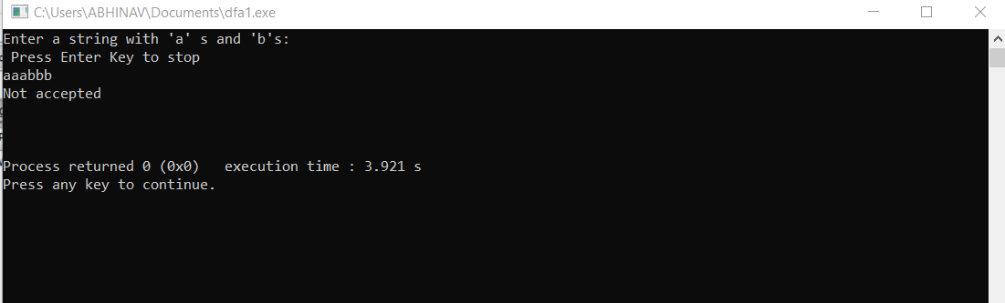

RESULT:- The C Program to simulate DFA has been successfully executed.